Batch: B3 Roll No.: 16010122158

Experiment No. 05

TITLE: Different Methods in PHP

AIM: The aim of this experiment is to evaluate and compare the effectiveness and security implications of using different methods in PHP.
______________________________________________________________________
Expected Outcome of Experiment:
The expected outcomes aim to enhance understanding of the implications and trade-offs associated with different methods of form data handling in PHP.

Books/ Journals/ Websites referred:
- https://www.php.net/docs.php
_____________________________________________________________________

Problem Statement: Description of the application implemented with output:

1. Develop a simple HTML form that collects personal information such as name, email, and age.
2. Create separate PHP scripts to handle form submission and data retrieval for each method: post_form.php, get_form.php, and request_form.php
3. Each script will process the form data according to the respective method ($_POST, $_GET, or $_REQUEST) and output the submitted information.

Implementation and screen shots of output

Code

index.html

<!DOCTYPE html>
<html lang="en">
<head>
<meta charset="UTF-8">
<meta name="viewport" content="width=device-width, initial-scale=1.0">
<title>Personal Information Form</title>
</head>
<body>
<h2>Enter Your Personal Information</h2>
<form action="post_form.php" method="post">
<label for="name">Name:</label>
<input type="text" id="name" name="name"><br><br>
<label for="email">Email:</label>
<input type="email" id="email" name="email"><br><br>
<label for="age">Age:</label>
<input type="number" id="age" name="age"><br><br>
<input type="submit" value="Submit">
</form>
</body>
</html>

post_form.php

<!DOCTYPE html>
<html lang="en">
<head>
<meta charset="UTF-8">
<meta name="viewport" content="width=device-width, initial-scale=1.0">
<title>Submitted Information</title>
</head>
<body>
<h2>Submitted Information (POST Method)</h2>
<?php
if ($_SERVER["REQUEST_METHOD"] == "POST") {
$name = $_POST['name'];
$email = $_POST['email'];
$age = $_POST['age'];

echo "<p>Name: $name</p>";
echo "<p>Email: $email</p>";
echo "<p>Age: $age</p>";
} else {
echo "<p>No form data submitted.</p>";
}
?>
</body>
</html>

get_form.php

<!DOCTYPE html>
<html lang="en">
<head>
<meta charset="UTF-8">
<meta name="viewport" content="width=device-width, initial-scale=1.0">
<title>Submitted Information</title>
</head>
<body>
<h2>Submitted Information (GET Method)</h2>
<?php
if ($_SERVER["REQUEST_METHOD"] == "GET") {
$name = $_GET['name'];
$email = $_GET['email'];
$age = $_GET['age'];

echo "<p>Name: $name</p>";
echo "<p>Email: $email</p>";
echo "<p>Age: $age</p>";
} else {
echo "<p>No form data submitted.</p>";
}
?>
</body>
</html>

request_form.php

<!DOCTYPE html>
<html lang="en">
<head>
<meta charset="UTF-8">
<meta name="viewport" content="width=device-width, initial-scale=1.0">
<title>Submitted Information</title>
</head>
<body>
<h2>Submitted Information (REQUEST Method)</h2>
<?php
if ($_SERVER["REQUEST_METHOD"] == "POST" || $_SERVER["REQUEST_METHOD"] == "GET") {
$name = $_REQUEST['name'];
$email = $_REQUEST['email'];
$age = $_REQUEST['age'];

echo "<p>Name: $name</p>";
echo "<p>Email: $email</p>";
echo "<p>Age: $age</p>";
} else {
echo "<p>No form data submitted.</p>";
}
?>
</body>
</html>

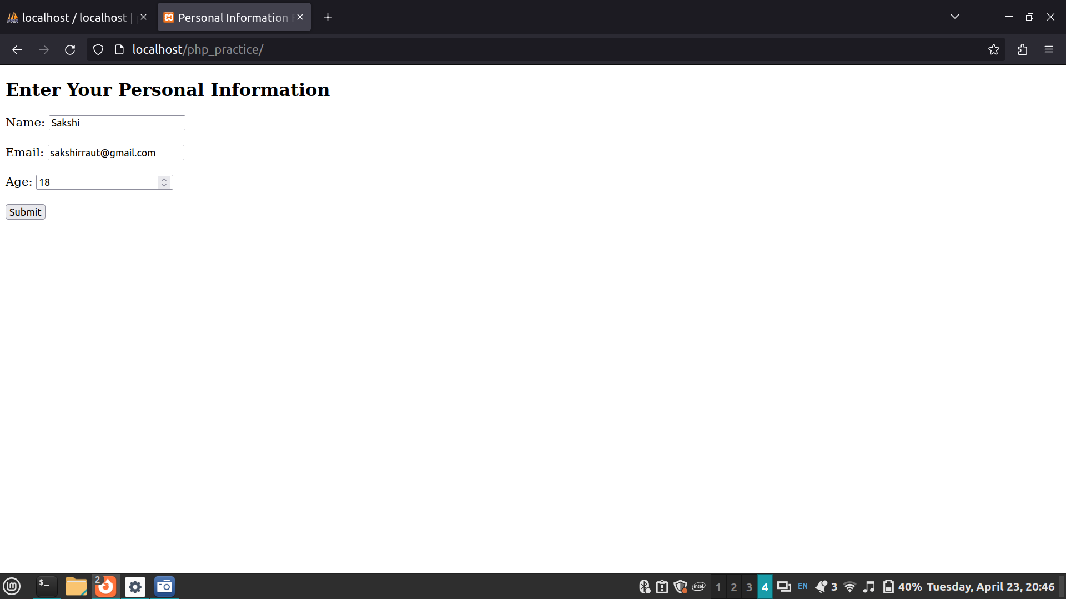

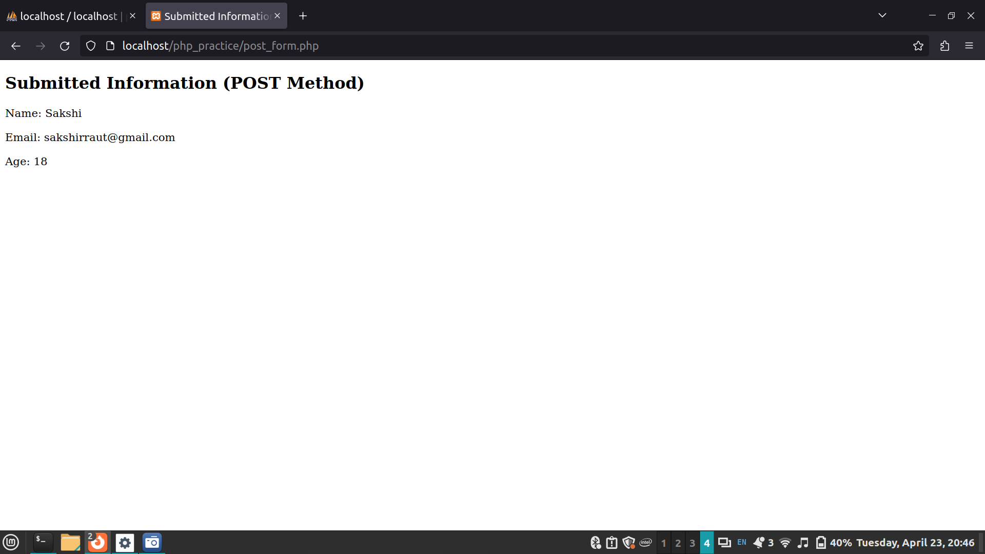

Post Lab Objective with Ans :
1.Which method ($_POST, $_GET, $_REQUEST) demonstrated the highest level of security, and why?
Answer:
Among the three methods ($_POST, $_GET, $_REQUEST), $_POST generally demonstrates the highest level of security. This is because data sent via POST method is not visible in the URL, unlike the GET method, which appends data to the URL. Therefore, sensitive information such as passwords or user credentials should be transmitted using POST to prevent them from being exposed in the URL or stored in browser history.
2. From a developer's perspective, which method ($_POST, $_GET, $_REQUEST) is the most convenient to implement and maintain?
Answer:
From a developer's perspective, $_POST is often the most convenient method to implement and maintain, especially for handling form submissions and transmitting sensitive data. With POST, developers can access form data via the $_POST superglobal array, which contains all form field values submitted by the user. Additionally, using POST allows developers to send larger amounts of data compared to GET, which has a URL length limitation. However, the choice of method depends on the specific requirements of the application and the type of data being transmitted.

